TEAM 11: Design Review 2

# System Design

The core systems identified in our current design are:

* The movement system, allowing us to move along a predetermined path. A simple 2 wheel assisted by 2 casters design has been adopted, assisted by 2 tape sensors in the front to be able to navigate in a straight line.

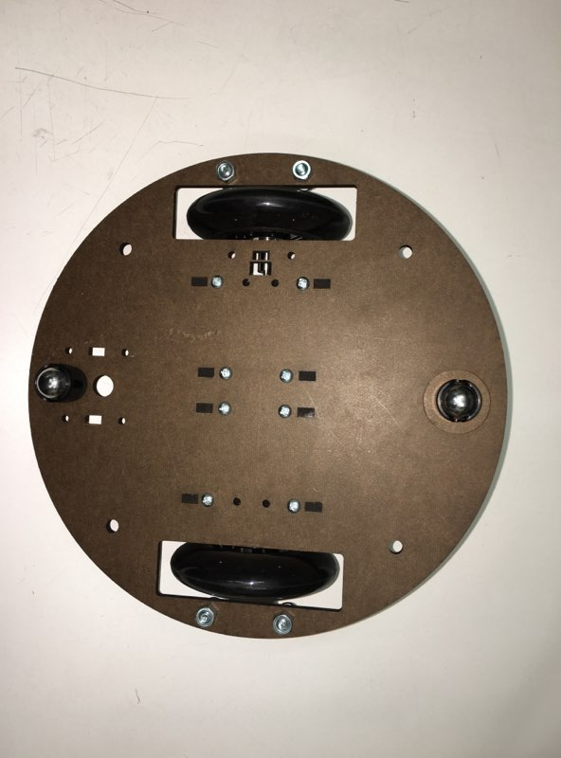

Figure Wheel Design

* An additional tape sensor for localisation (more on this in the software part)
* The buzzword dispenser, yet to be implemented, which will dispatch the balls in the appropriate bins. The current design is a simple solenoid blocking a ramp where the balls are placed.

To be competitive in the competition, two additional systems should be added:

* A beacon reading system, allowing us to understand the game state to take more appropriate decisions. We will use a rotating phototransistor that point at one beacon at a time.
* The “super like”, our special feature allowing us to tilt the scales of each round. More details in the near future.
* 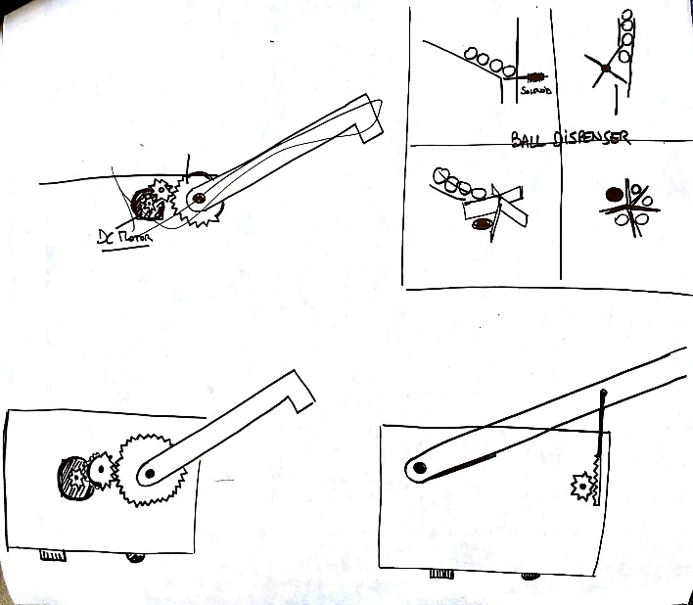

Figure Dispenser and Super Like Design

# Mechanical Design

Our mechanical designed has been finalized as a CAD before construction assisted by laser cutters.

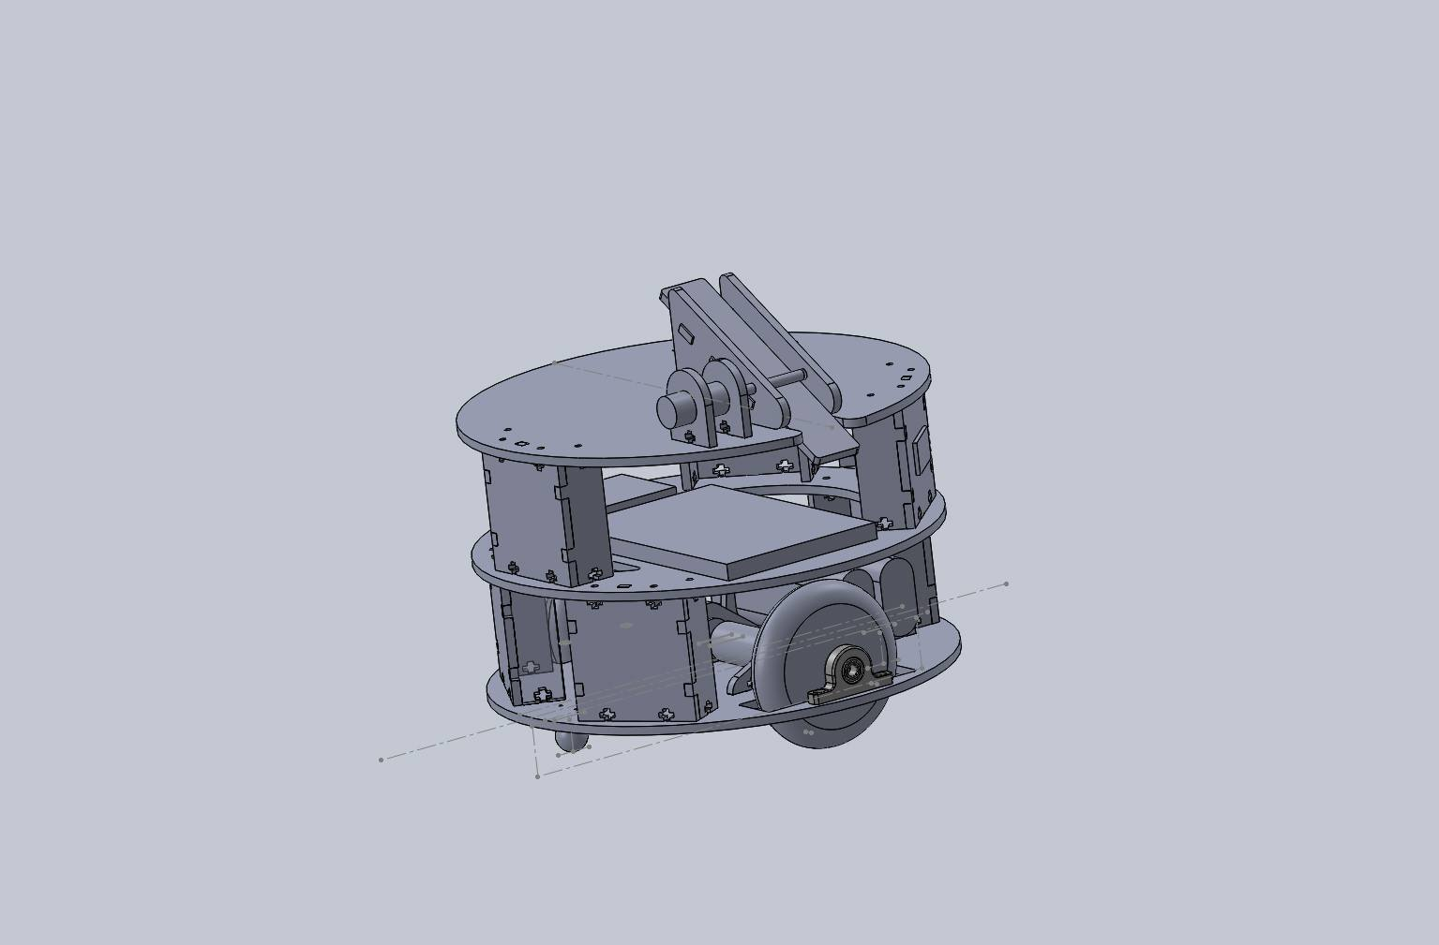

Figure CAD

It is a 3 layer cylindrical design. The lower level holds the motors and wheel, the second the electronics and the third the buzzword dispatch system.

The mechanical structure has been designed for easy assembly and disassembly. It also includes slots for batteries, sensors and electronic components.

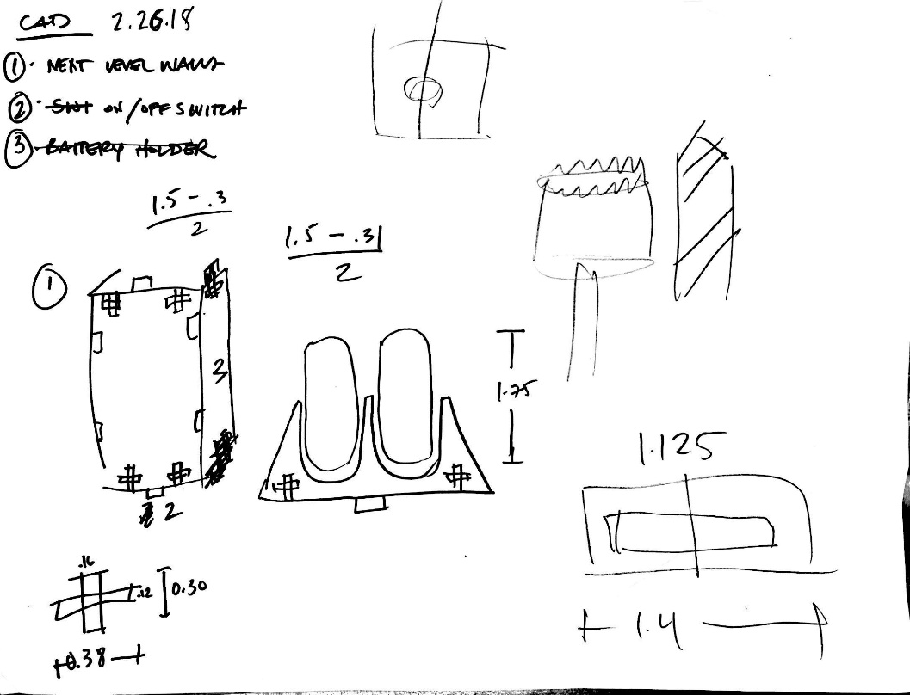

Figure Structure and Battery Holder Design Sketches

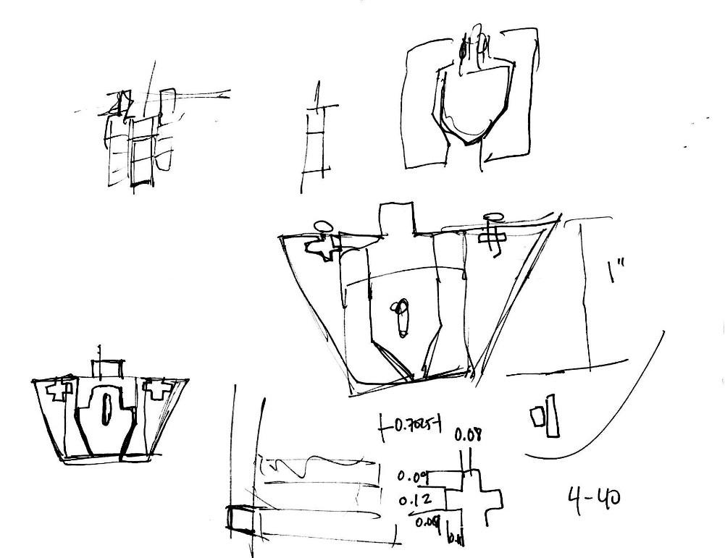

Figure Sensor Holder Design

# Electronic Design

# Software Design

In order to make software development and debugging manageable, each subsystem is treated independently before integration. They all present a number of states and action triggers. We then plan to add a “game strategy” layer that will govern the rest of the subsystem code. We have currently implemented:

* The movement code, which is so far so most complex one. We are using a closed loop approach to make sure our robot follows a straight line. Essentially, the voltage applied to each wheel is a nominal value, plus or minus a control value computed by our controller. In our most recent iteration, we test whether each side’s reading is above or below a threshold and multiply the difference of the results by a gain. In terms of states, we have one state for forward, one for backwards and one for rotation. The transitions will be controlled at the game playing level.
* The positioning code iterates between areas of the playing field. Essentially we have a variable that increases as we move forward, adding 1 when entering an horizontal piece of tape, and removing 1 after leaving it. This also gives additional information as even values are on crossing while odd are not. We however added a state that indicates whether we are on a crossing tape or not.
* The last set of functions currently incorporated are control the solenoid. The solenoid has states open and closed.

# Preliminary Testing Results

As of today, the robot has proven that it can follow the lines as well as update its position. A few additional conclusions have been drawn from the tests:

* A PID controller based on the values of each tape sensor (phototransistor) is not a good way to follow the lines, as we have not accurately calibrated the sensors. As such, there will always be an offset between the readings on the right and on the left, making it impossible to follow the line. The current approach is far more reliable, even without D and I terms.
* Because of the green tape lines, the current approach to position detection is not fully reliable. Tuning the thresholds should fix the issue.
* One of our motors has died and will need to be replaced.
* It is possible to fry resistors it turns out.